

**Sultan Qaboos University**

**College of Science**

**Department of Computer Science**

**COMP3700: Introduction to Web Computing**

**Fall 2022**

**Project- 4:**

PHP SUNSET hotel

**Name:**   **ID:**

Ya’Rab Mohammed Al Mamri 130376

Qusai Al-Toobi 131791

Ali Hamad Al-Harrasi 131495

Contents

**Page1** 3

**Page2** 6

**Page3** 8

**Page4** 12

**Contributions:** 13

# Page1

We have updated the Booking from the last parts, like the code checks if the user searching number of beds or a range of price, display the result and other information about the rooms. Additionally, in this page PHP check the information that comes from Sign up page and Login page to return to them if some information empty.

Also when it takes the information from login page it search for user in the database to fetch his/her information.

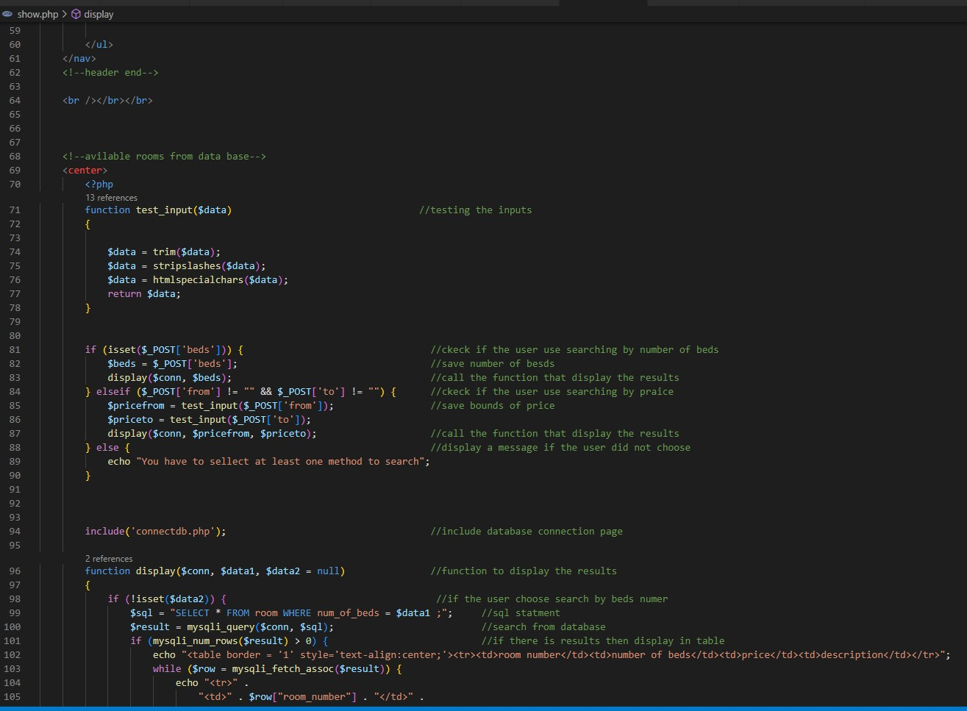

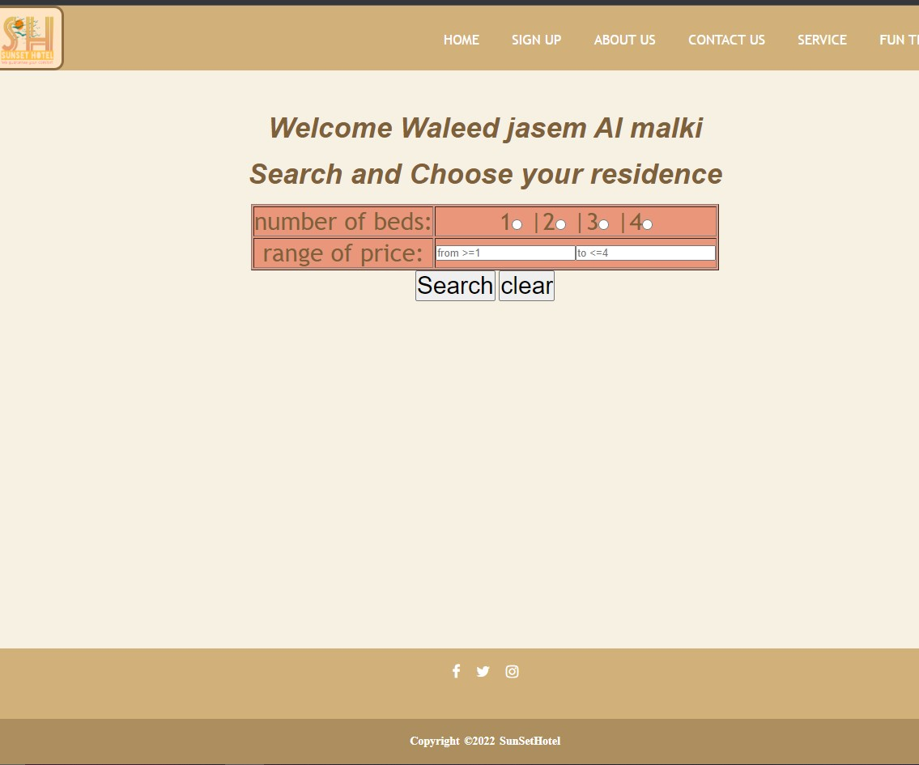

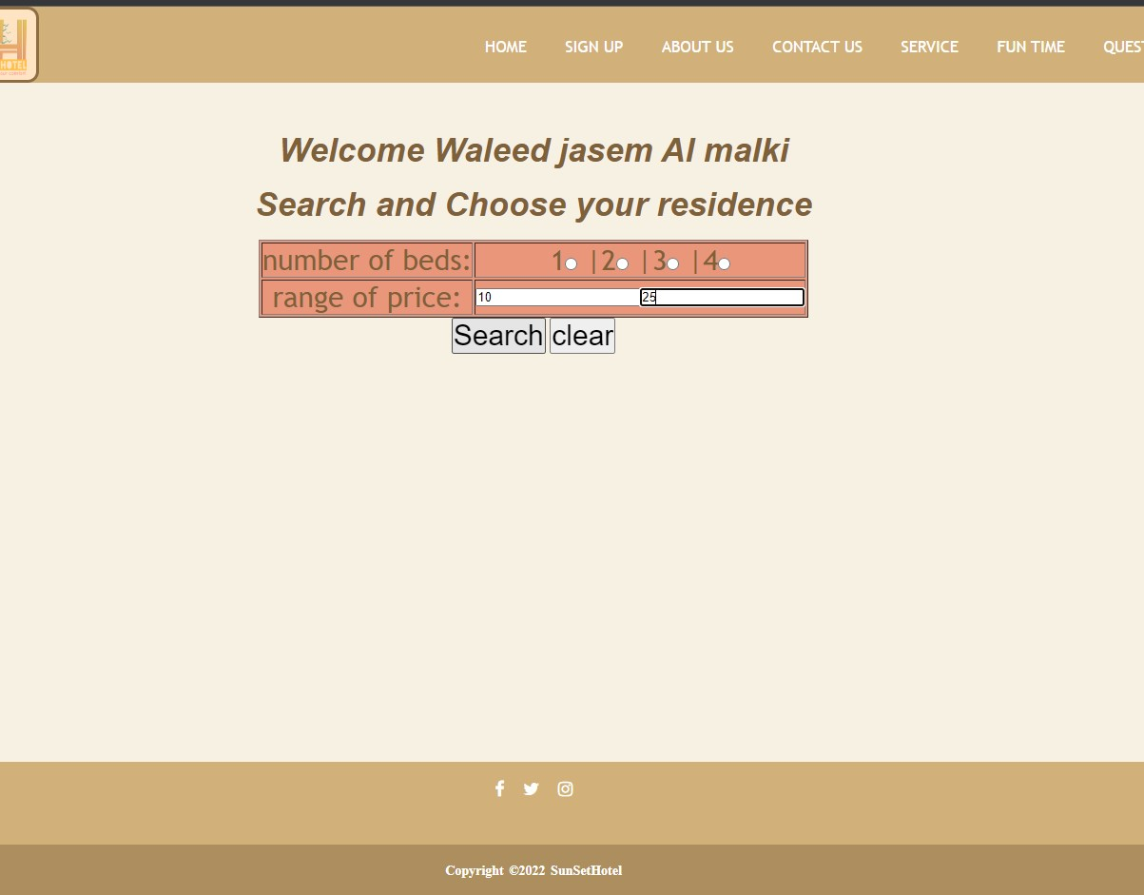

We have updated sign up page that move to Booking page, display the name on the top of the page and insert new user information into the database.

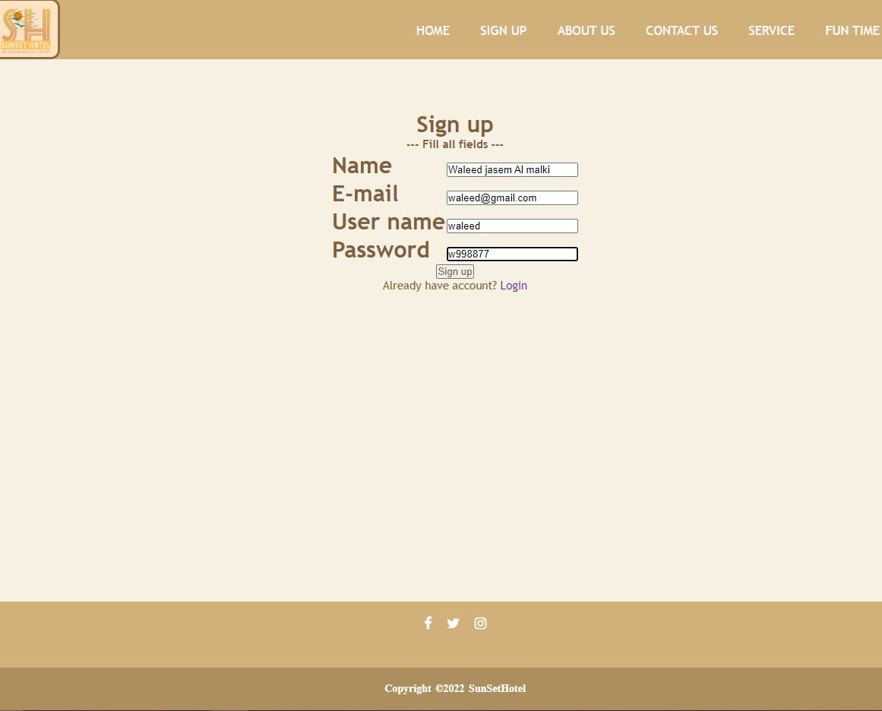

These pictures shows before and after we sign up new client.

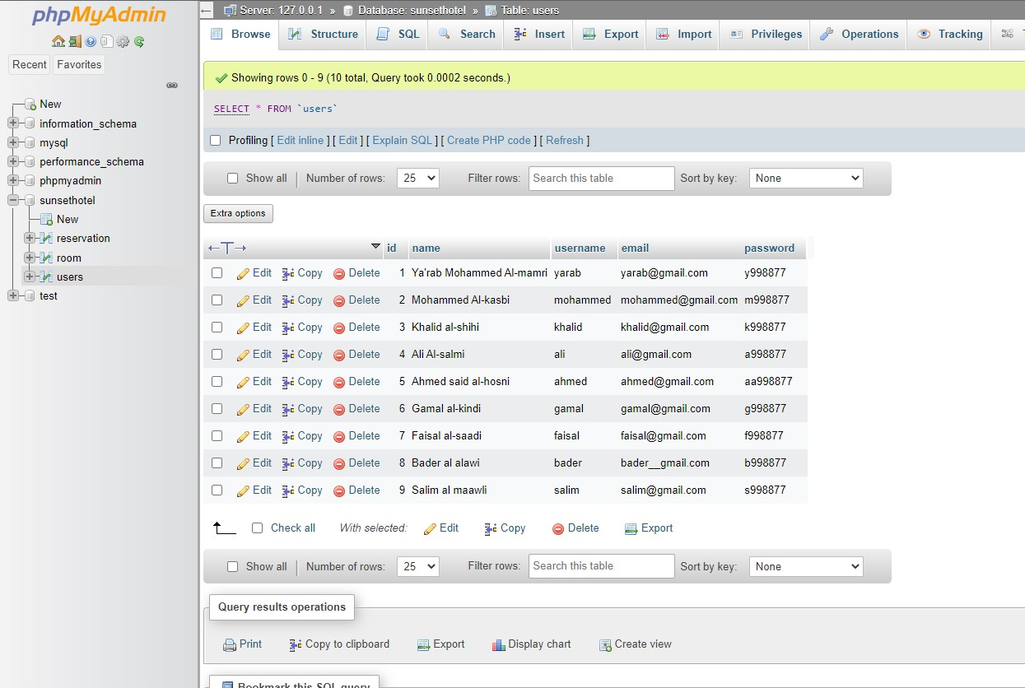

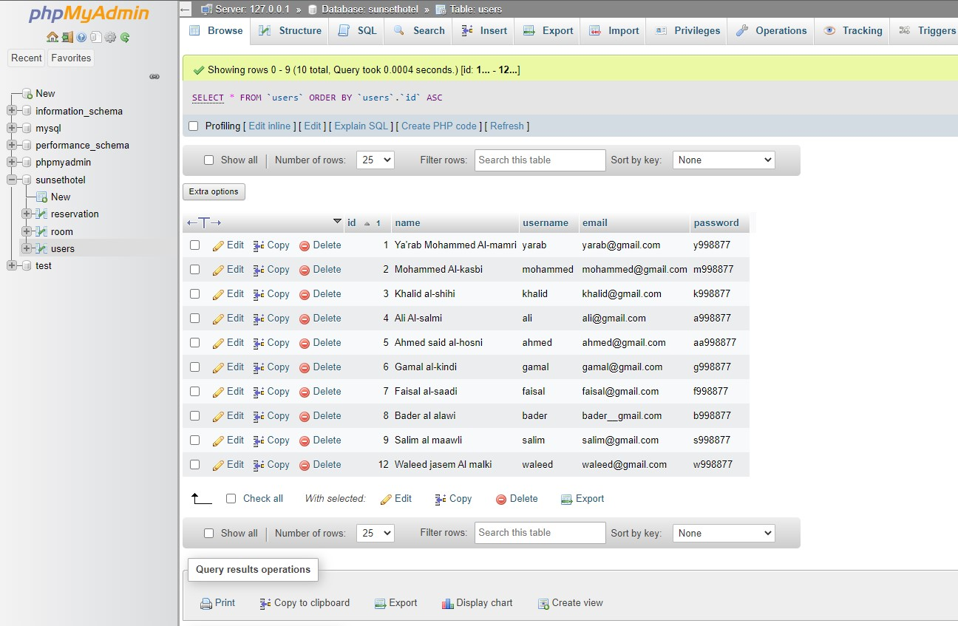

# Page2

We use this page to connect to the database so that we use it in different pages after.

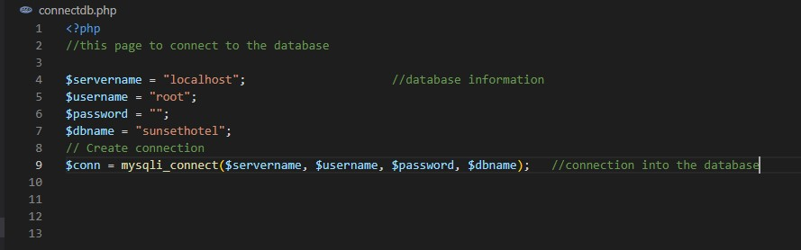

# Page3

This page process the answers from Question page and shows them in table and check if one of the fields is empty appear a message for the user.

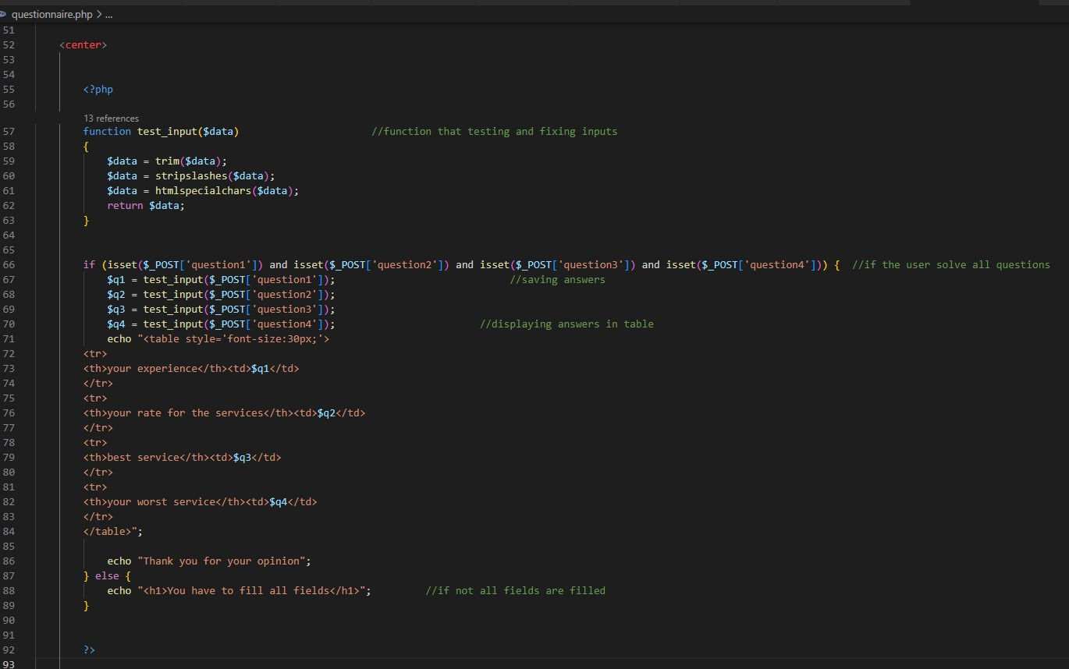

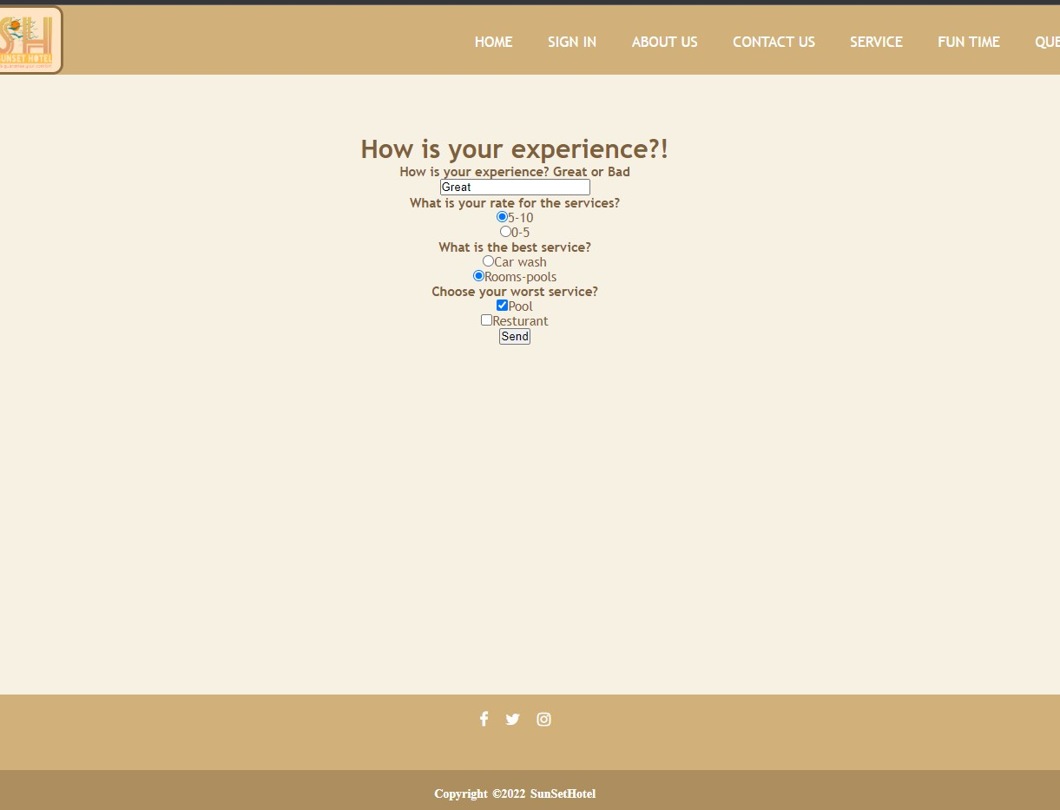

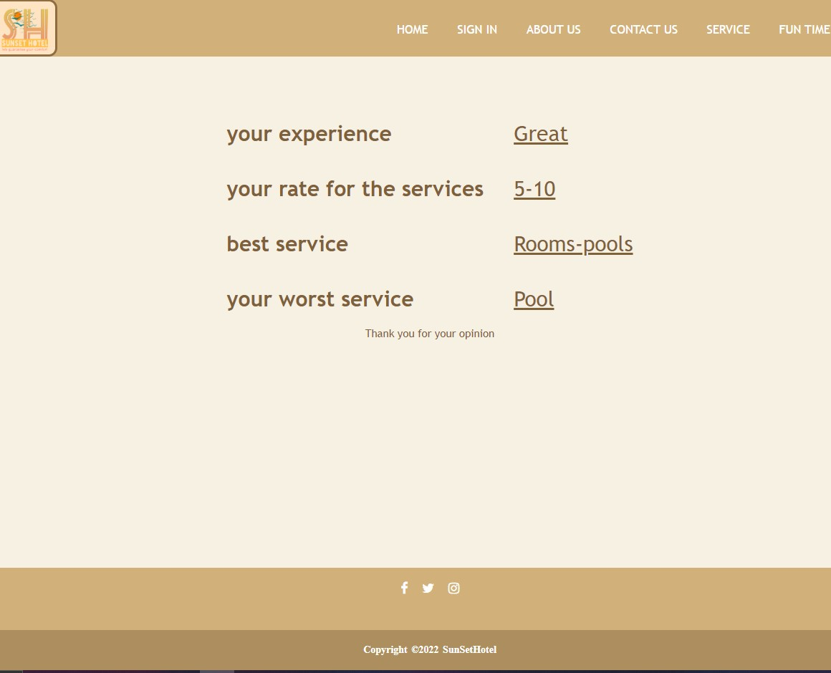

# Page4

This is show.php page, this page shows the results for user searching ,it take the information from Booking page and search and fetch the information from the database and shows them in a table.



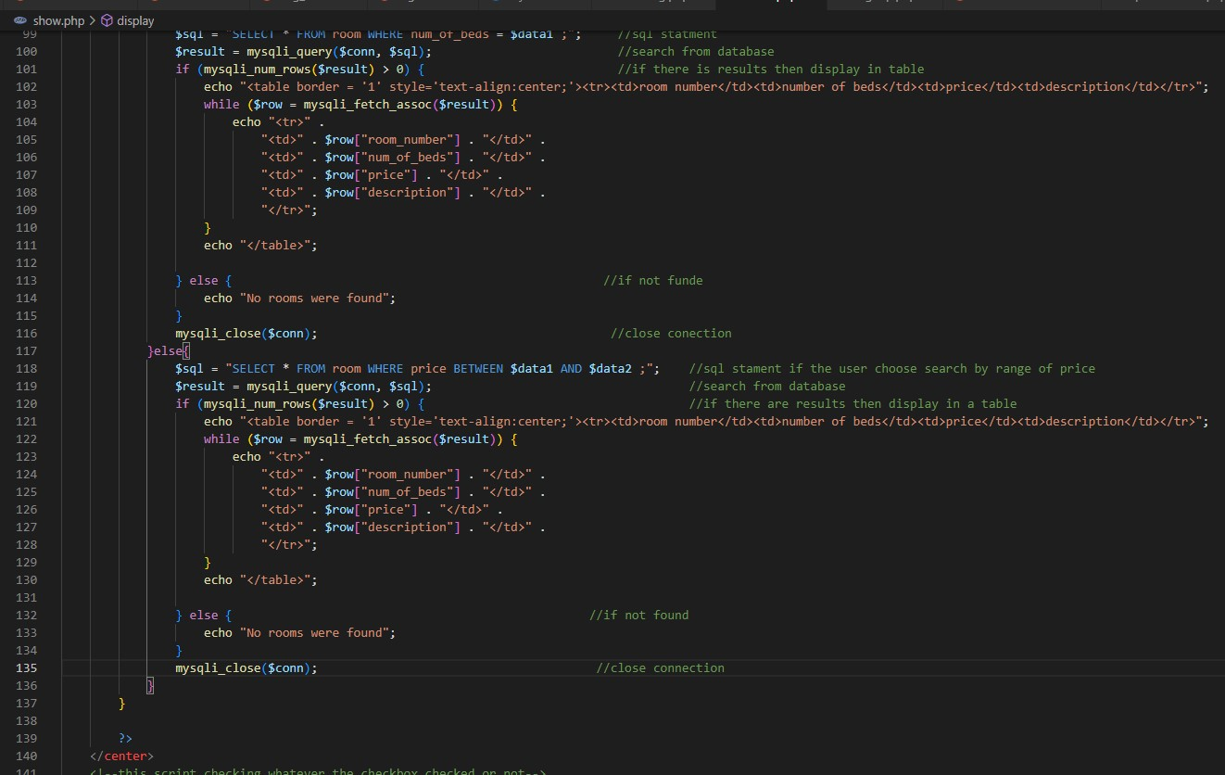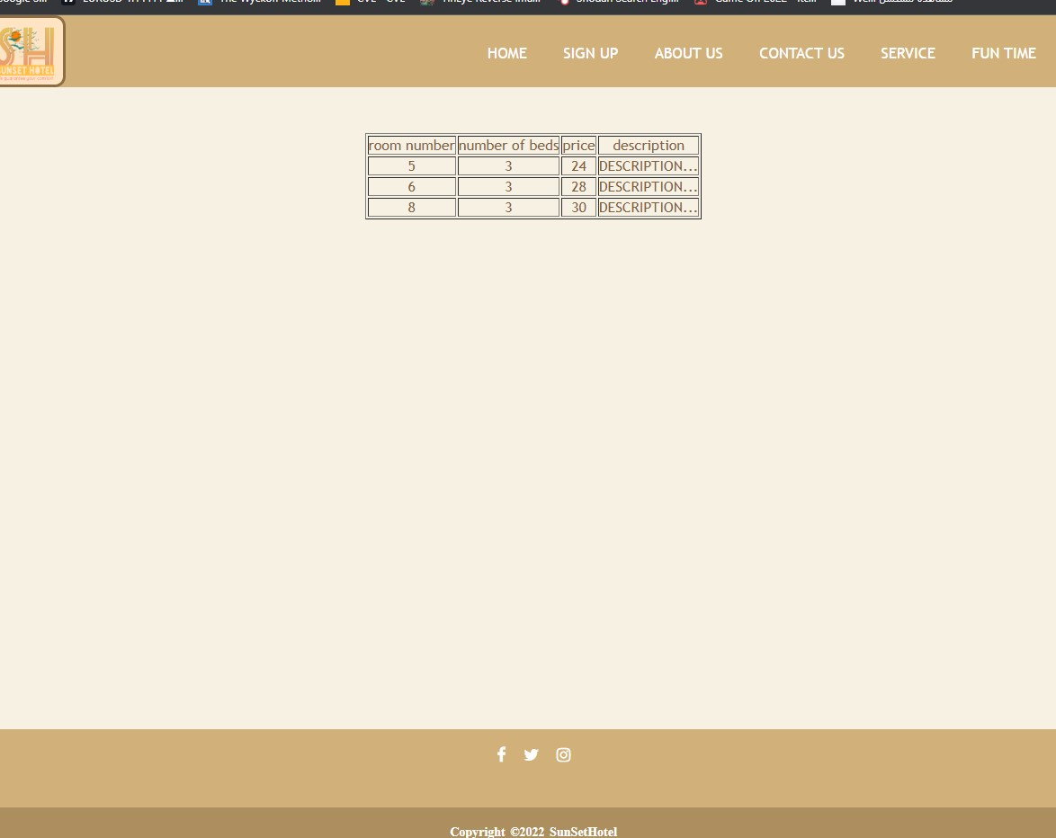

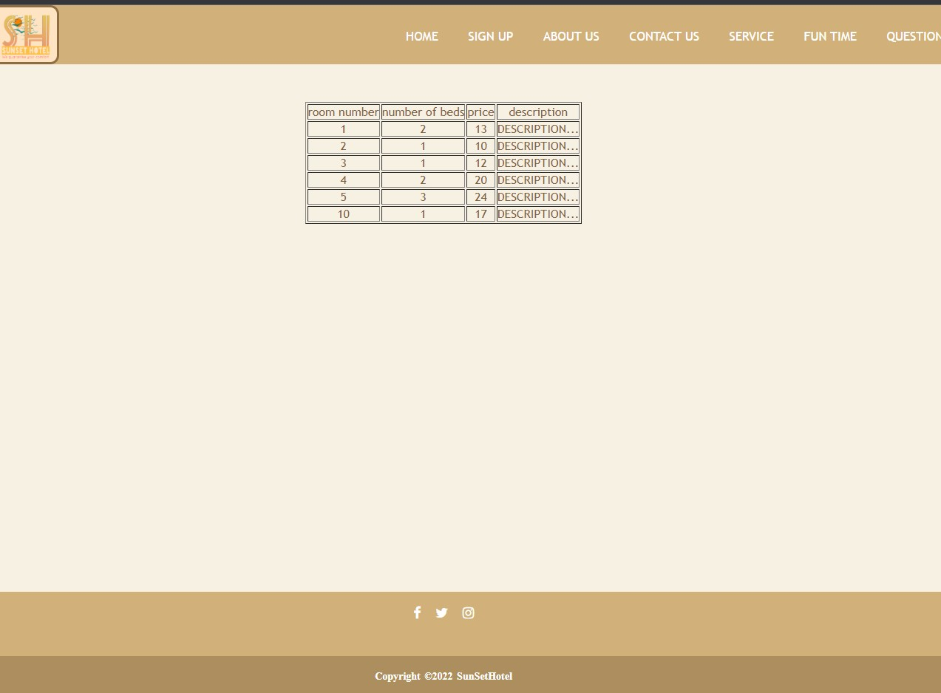

**Webhosting link:** [**https://juniorprice.github.io/Web-project/**](https://juniorprice.github.io/Web-project/)

# Contributions:

|  |  |  |  |  |
| --- | --- | --- | --- | --- |
|  | Page 1 | Page 2 | Page 3 | Page 4 |
| **Ya’Rab**  **Mohammed**  **Al Mamri** | **40%** | **20%** | **10%** | **70%** |
| **Qusai AlToobi** | **30%** | **70%** | **10%** | **15%** |
| **Ali Hamad Al-Harrasi** | **30%** | **10%** | **70%** | **15%** |